|  |
| --- |
| George Washington University |
| Evaluating Machine Learning Methodologies for Predicting Metal Commodities Pricing |
|  |

|  |
| --- |
| Rich Gude, M.S.  5-5-2021 |

# Abstract

Academic literature investigating the efficacy of regression, autoregressive, and machine learning models for predicting commodity price fluctuations has had mixed results, with some papers identifying statistically significant improvements in commodity forecasting versus a variety of baseline models and still others critiquing published results for a lack of out-of-sample robustness. This study seeks to add to the literature of machine learning techniques for forecasting commodities prices by investigating the efficacy of Recurrent Neural Networks (RNNs) derived from commodity price data for five industrial metal commodities (aluminum, copper, iron ore, nickel, and zinc) and economic feature data against a standard autoregressive, integrated, moving average (ARIMA) model derived from the same set of industrial metal commodity price data.

Autoregressive analysis for each set of commodity data identified a random walk trend (i.e., an ARIMA(0,1,0) model with no trend constant) for each. With three (3) RNN models derived for each commodity utilizing different combinations of correlated economic features, RNN models were not found to be superior for forecasting commodity prices over a random walk method; only one (1) RNN model out of fifteen (15) was shown to be statistically superior to baseline random walk models for the testing commodity data (an RNN model for nickel prices utilizing no economic feature data). Testing suggests that the fundamental nature of industrial commodity data is a random walk model.

# Introduction

The benefits of understanding volatility in financial markets and predicting commodity prices for investors and industrial producers and manufacturers are numerous. Recognizing the trends of metal commodity prices, such as aluminum, copper, and iron – the three largest industrial metals markets, allows wholesale metal alloy producers to recognize the appropriate time over which to buy or sell stock or product, respectively. Time series and feature selection methods are common analyses for prediction of commodity prices (Bessembinder & Chan, 1992; Chen, Rogoff, & Rossi, 2010; Gargano & Timmermann, 2014).

## Commodity Price Considerations and Literature Review

The economic features studied in commodity prediction literature include global economic activity, futures prices, interest rates, exchange rates, inventory, open interest in futures markets, and other variables, both commodity-specific and not (Wang Y., 2020). It is worth cautiously acknowledging the value of economic feature prediction models may be tempered in some respects as well. Despite the propensity of predictive studies and the often-reported statistically-significant gains of time and feature-dependent models over baselines, Welch and Goyal in a meta-analysis review of many of study methods and data show limited model performance for in-sample and out-of-sample prediction upon re-evaluation and re-testing (2008). These study authors caution that seemingly statistically-significant models for various data and over various times may been found, but a “healthy skepticism” of derived models is appropriate.

Further confounding the role of economic features on price is the more recent ‘financialization’ of commodities markets. Following the dot com and housing bubble financial crises of the early and late 2000s, respectively, investors on the whole began to build up assets in the commodities markets. This increased institutional participation of investment into commodities, along with advances in technologies and financial engineering, began to fundamentally alter the relationships and correlations between commodities and traditional asset markets. As a recent phenomenon, the role of financialization on the volatility of commodities prices and the correlation of individual economic features to price starting in the 2010s is unknown with the empirical literature to date being divided (Shamsher, 2021).

Another method for predicting commodity prices is using technical trading rules to identify autoregressive trends within the pricing data itself. Efforts to explore and forecast commodity indices from trading rules – sell and buy commands set to mimic the behavior of investors – have shown statistically-robust predictions, even accounting for various markets and against baseline economic feature models. These rules identify buying and selling commands based on whether the current price is greater than a lagged price (*momentum* rule), the current price exceeds a certain threshold value against surrounding values (*filter* rule), recent fluctuations in commodity prices may have precipitous follow-on effects (*oscillator* rule), and others (Wang Y., 2020).

Economic theories can tie the correlation between some economic features or technical rules and price with causation vice mere correlation. The “carry trade” model of commodity prices, for instance, hypothesizes that low, real US interest rates signal to commodity speculators that investment money is plentiful and storage costs for physical assets are low, thus increasing commodity demand for commodities and driving up commodity prices (Frankel, 2014). The bases for technical trading rules have economic justification as well, linking momentum, filter, and oscillatory rules to the rate at which investors receive information, react to the indications from other investors, and consistently under or over-react in certain trading situations (Wang Y., 2020).

Feature and trading rules appear to be separate from financial speculation and irregular economic boom or recession effects. For metal commodities pricing in particular, meta-analysis shows no statistically-significant effect of financial speculation on price forecasting (Wimmer, Geyer-Klingeberg, Hütter, Schmid, & Rathgeber, 2020; Hall & Rust, 2021). Shocks to individual commodities markets are common due to emerging production or supply news (Home, 2021; MINING.COM, 2021) or greater economy-wide slumps (Furlong & Ingenito, 1996; Chambers & Bailey, 1996); however, these effects are generally outside the ability of most commodity prediction models, lacking the complexity or predictive features necessary to forecast the specific aberrant price fluctuations.

## Machine Learning Prediction

Machine learning prediction methods employ advanced computational, mathematical, and statistical techniques to discover underlying trends or relationships within data and improve prediction capabilities.

These methods have, to date, been used sparingly in scholarly reports, with mixed results against traditional modeling techniques: Herrera et al compare the efficacy of a simple random forest prediction model utilizing energy price data to an advanced neural network model for outperforming traditional econometric forecasting methods; the random forest model significantly outperformed the neural network and traditional models when optimizing for mean square error (MSE) and, additionally, were able to mimic technical trade rule trends, such as predicting price turning points (2019). Conversely, Ferrari, Ravazzolo, and Vespignani used an advanced, non-machine learning, dynamic sparse factor model for forecasting energy prices, showing significant gains for this model over elastic net, LASSO, and random forest control models in one-month-ahead forecasting (2021).

Noted in the literature, economic models may suffer from “the curse of dimensionality”, none more so than machine learning models, especially heavily parameterized neural networks. The issue of having many variables and model parameters for a given size of price data is nontrivial, since models can be overfit to training data, and subsequently perform very poorly for out-of-sample validation and testing. Methods for dimension reduction, such as feature selection or principal component analysis are common, with feature selection showing better forecasting results in some cases (Liang, Ma, Li, & Li, 2020).

## Study Purpose

This study seeks to add to the literature of machine learning techniques for forecasting commodities prices by investigating the efficacy of machine learning methods particularly suited for time series modeling, namely Recurrent Neural Networks (RNNs), against a standard autoregressive, integrated, moving average (ARIMA) model derived from the same set of industrial metal commodity price data and economic feature data. Although separately derived herein, the appropriate ARIMA model derived from commodities price data is found to be an ARIMA(0,1,0) model without a statistically-significant constant, or a *random walk*. Representing commodities fluctuations as a random walk is consistent with literature (Alexander, 1961).

# Research Methodology

## Price Data and Analysis

Commodities price data originates from the International Monetary Fund (IMF), obtained through the Federal Reserve Bank of St. Louis: Economic Research (FRBSL) division. Price data represents the monthly global market price of various industrial metal commodities from January 1990 to December 2020, measured in non-seasonally-adjusted, current United States dollars (US$) per metric ton. The five industrial metal commodities selected for this research are aluminum, copper, iron ore, nickel, and zinc metals. Aluminum, copper, iron ore, and zinc represent the four largest industrial metal markets, and nickel has special importance to certain alloys markets as well as a large stake in growing batteries markets (USGS, 2021).

Besides simple exporting from Microsoft Excel format, price data was further altered to the ‘real’ (i.e., inflation-adjusted), 1990-equivalent commodity price by dividing each monthly commodity price by the ratio of the monthly Consumer Price Index (CPI) from the current month and the January-1990 value. CPI values were also obtained from the FRBSL. Converting to real commodity prices is a standard method for price analyses; real prices, in a meta-analysis of commodity price datasets, are shown to be stationary, which is necessary for further autoregressive modeling (Winkelried, 2021).

Figure 1 shows the 1990-equivalent, ‘real’ commodity prices for aluminum, copper, iron ore, nickel, and zinc over the time frame of the study data (1990 to 2021) on a log-scale-value plot:

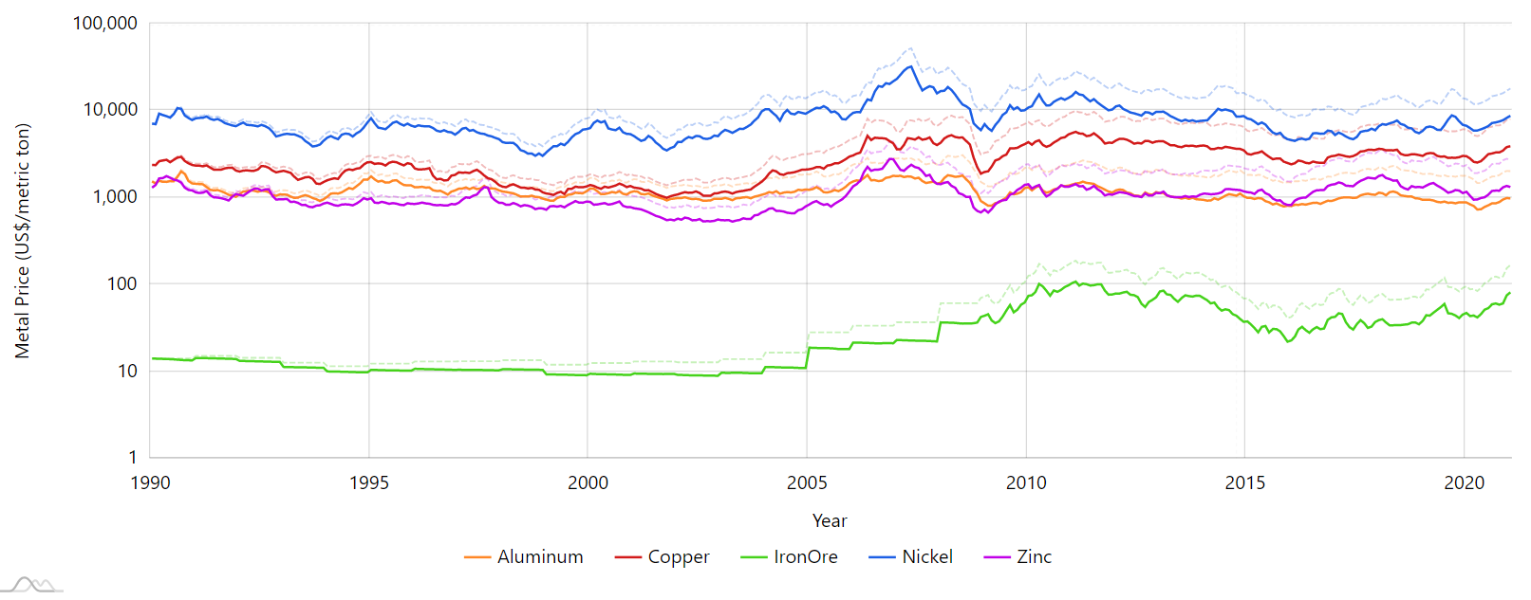

**Figure 1:** The effect of inflation on present-day (dashed) to 1990-equivalent (solid), 'real' commodity prices for Aluminum, Copper, Iron Ore, Nickel, and Zinc

As seen in the figure above, the role of inflation on pricing, commodity or otherwise, is quite significant over time: the current-year price of nickel (US$ per metric ton) in January 2021 is $17,863, but the inflation-adjusted, 1990-equivalent price is $8685; that is a drop in value of roughly half of the current-year price (51.4%). Most importantly for modeling and analysis purposes, this percentage drop in value is consistent across all analyzed metal commodities and, for that reason, not significant for understanding the variable effects of inflation on certain commodities or in certain time periods. For future model building and analyses, the 1990-equivalent, ‘real’ prices of each commodity are used.

Except for iron ore, the real price of each commodity is seen to be relatively stable: the final three-month-average (from December 2020 to February 2021) of each commodity price compared to its beginning three-month-average starting in January 1990 for nickel and zinc changed by less than 10% of their starting values (+6.12% and -8.24%, respectively) and copper and aluminum were also only moderately affected (+52.0% and -36.0% changes, respectively). This reflects research into the volatility of commodity prices by the S&P Dow Jones Indices research division that commodity prices tend to vary only moderately over time (Boal & Wiederhold, 2020). In this way, price data is relatively stationary.

## Economic Feature Data and Analysis

The collection of economic feature data considered in this report comes from the meta-analysis research of Welch and Goyal (2008). From the work of Welch and Goyal, fourteen (14) economic features are evaluated for significance for predicting market indices and premiums; these economic features, and their short-hand notations used in figures, are: S&P 500 12-month moving sums of dividends (*D12*) and earnings (*E12*); the book-to-market value ratio of the Dow Jones Industrial Average (*b/m*); the 3-month treasury bill, secondary market rate (*tbl*); AAA (*AAA*) and BAA-rated (*BAA*) bond yields; long-term government bond yields (*lty*); the net equity expansion from the New York Stock Exchange (*ntis*); risk-free rate (*Rfree*); inflation (*infl*); long-term government (*ltr*) and corporate (*corpr*) bond returns; S&P 500 daily stock variance (*svar*); and S&P 500 index prices (*SPvw*).

Features were either published from or computed by a variety of sources and collected and distributed by the office of Amit Goyal at his personal website (Goyal, 2020). Economic features are recorded monthly from January 1990 through December 2020. Figure 2 visualizes the spread of the normalized economic feature data along with normalized real aluminum price, for comparison.1

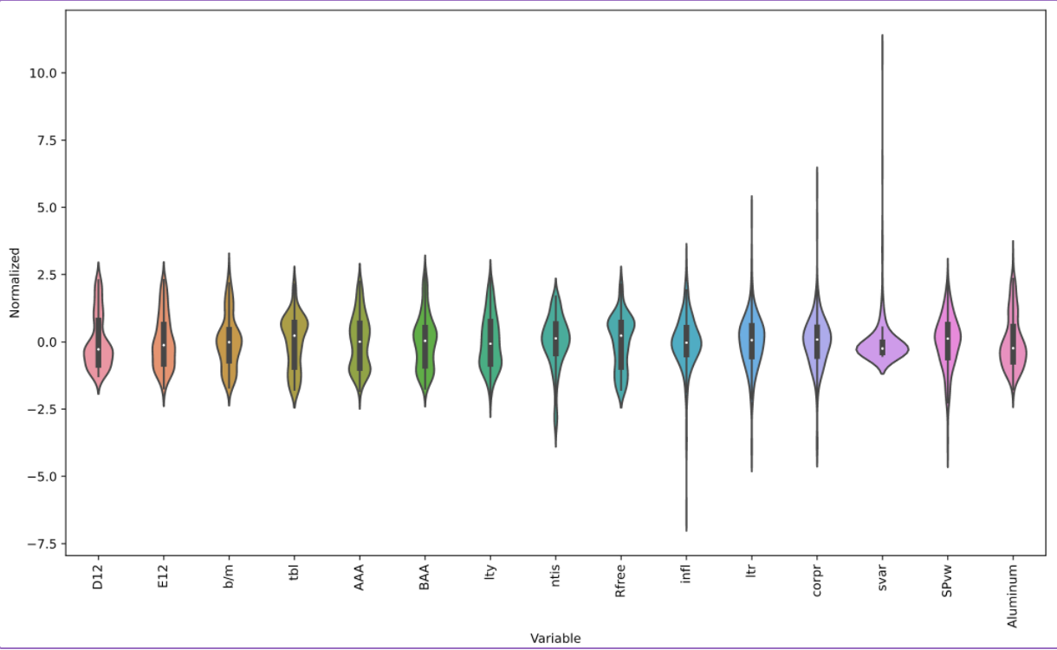

**Figure 2:** Violin Plot Showing Spread of Normalized Economic Feature Data with Normalized Aluminum Price for Comparison

1. Aluminum is chosen hereafter to compare economic feature data and showcase model building processes. Modeling for copper, iron ore, nickel, and zinc takes into account similar comparisons and processes.

Economic features with a comparable data spread in advance of a commodity’s price are likely to be highly influential in a price model. In this way, features such as S&P 500 dividends (D12) and long-term government bond yields (lty) *may* be highly weighted in an aluminum price model, as seen from the similar spread shapes in Figure 2; however, the violin chart does not identify when dividend or bond yield values may precede, proceed, or be completely independent of aluminum price values. For this, the correlation between economic features and aluminum price are more valuable. Figure 3 presents the correlation between each economic feature and the aluminum price.

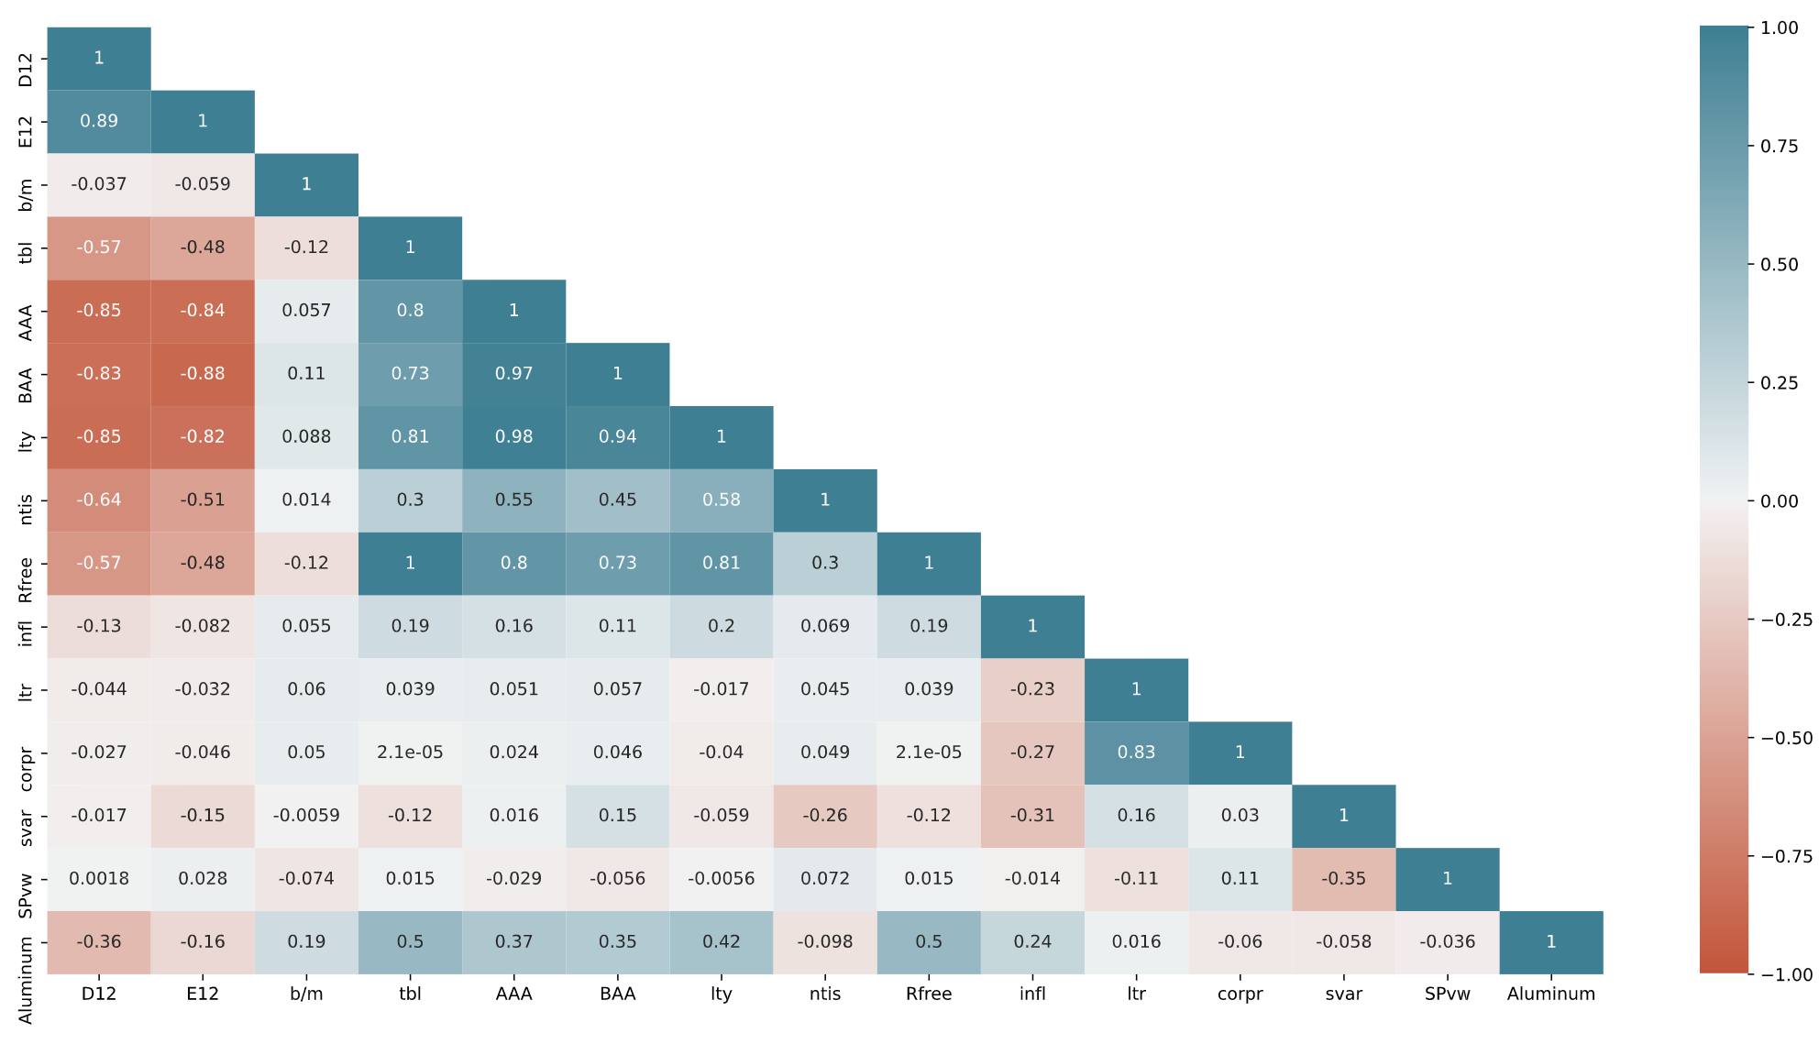

Figure 3: Correlation Matrix of Economic Features and Aluminum Price

From the bottom row of Figure 3, no economic feature has more than a moderate correlation (roughly ±0.5) with aluminum price. Worth considering, as well, is the highly correlated nature of many of the economic features: both the treasury bill (tbl) and risk-free rate (Rfree) have the greatest correlation with aluminum price, but these two features are completely correlated (i.e., identical); a model employing both of these features would be wasting computing resources (e.g., the kernel weighting for either features, if equal and opposite, would cancel each other out, obscuring their real effects on price if kernel weighting were observed and understood). Similarly, S&P 500 dividends (D12) and earnings (E12) are highly correlated along with AAA-rated, BAA-rated, and long-term government (ltr) bond yields.

Reducing the dimensionality of model data improves model robustness and limits overfitting. Highly correlated data may be subjected to dimensionality reduction in one of two ways: feature selection or principal component analysis (PCA). Liang, Ma, Li, and Li identified feature selection performed better than PCA in their analysis of commodity price forecasting (2020); accordingly, feature selection will be used in the following model analysis. Any combination of features with greater than 0.9 correlation will not be included within the same model; effectively, this eliminates earnings (E12), BAA-rated (BAA) and long-term government (ltr) bond yields, and the risk-free rate (Rfree) from model considerations, lowering the total number of economic features to ten (10) from fourteen (14).

## Research and Model Methodology

This project hypothesizes that machine learning models, specifically Recurrent Neural Networks (RNNs) particularly suited to time-series data, are superior to autoregressive, integrated, moving-average (ARIMA) methods for forecasting industrial metal commodities price data. To test this hypothesis, RNN and autoregressive commodity price models will be developed from up to six (6) months of previous price and/or economic feature data to forecast commodity price predictions out to six (6) months in the future. The efficacy of either model will be compared with the mean square error (MSE) of the residuals between each forecasted and actual commodity price out to six months. If the RNN model has a statistically-significant smaller MSE over the test data, chosen as the last three years of the data, compared to the ARIMA model, the machine learning model will be shown to be superior for forecasting commodity prices.

### Test Window

The total economic feature and commodity price dataset spans 360 shared monthly data points. The testing window is 36 monthly data points, representing ten percent (10%) of the total dataset. Since RNN and ARIMA models are being developed to predict out to six months based on the preceding six-month feature data, 36 monthly data points constitute 162 forecasted prices with the middle 26 months have six (6) predictions each and the first and last months within the testing window only having one (1) prediction each.

### ARIMA Models

ARIMA models consist of three components: the autoregressive, integrated, and moving average elements, each with an associated order, integer values P, Q, and D, respectively, corresponding to ARIMA(P,Q,D). Determining the order of each requires investigation of autocorrelation and partial autocorrelation function values as well as regression analysis and testing of derived model order coefficients. Figure 4 illustrates the autocorrelation and partial autocorrelation function values of aluminum prices out to 12 monthly lags (i.e., one year).

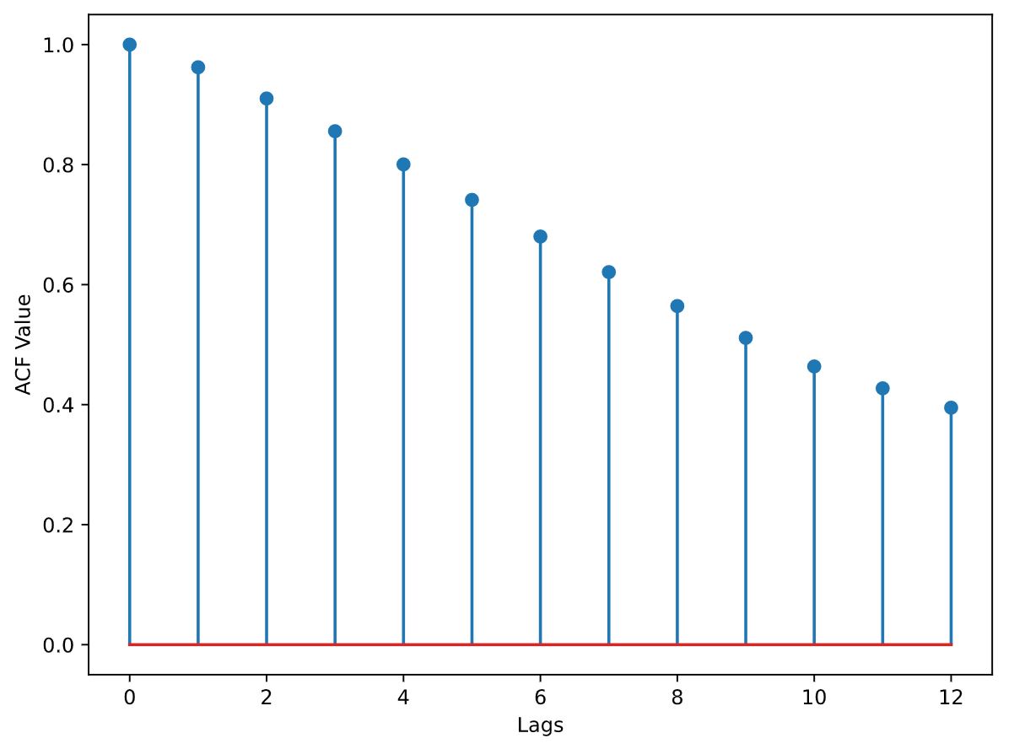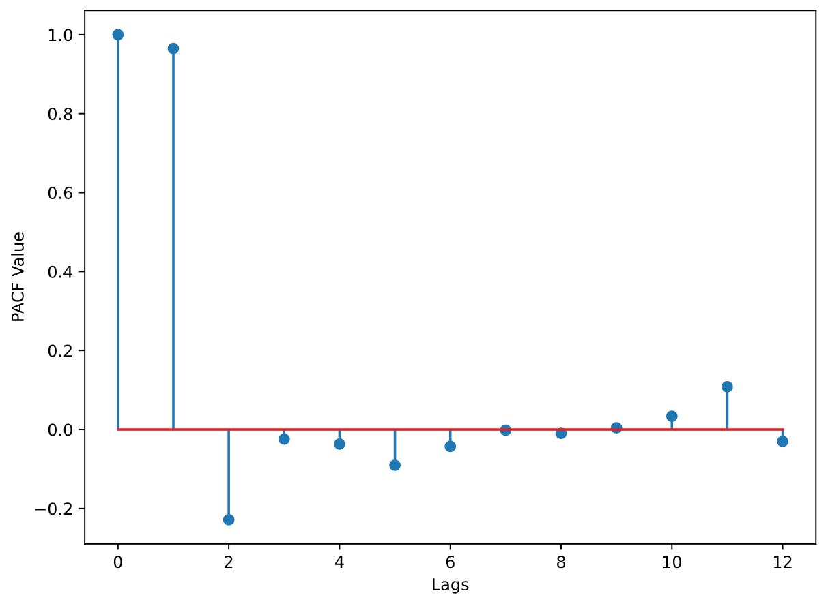

Figure 4: Autocorrelation and Partial Autocorrelation Function Values of Aluminum Prices out to 12 Lags (1 year)

From the large (i.e., significant) autocorrelation function values out to large lag values, there is a clear effect from the preceding months’ prices on the current aluminum price; however, from the large partial autocorrelation function value at only a lag of one month, the effect from the first preceding month is the only significant influence. Large, positive autocorrelations out to twelve monthly lags with a large partial autocorrelation at a single lag of 1 month indicate a larger order of differencing is necessary (i.e., increasing the integrated order, Q, from 0 to 1).

Autocorrelation and partial autocorrellation analysis of each commodity under review yielded similar results to the aluminum values. The ARIMA model order for each commodity was found to be not appreciably different from an ARIMA(0,1,0) model without a significant drift, that is a *random walk* model, after testing for autocorrelation and fitting ARIMA models of orders (0,1,0), (1,1,0), (0,1,1), and (1,1,1) using the Python ‘statsmodels.tsa’ libraries for deriving ARIMA model coefficients. In each commodity’s case, either the ARIMA(1,1,0) or ARIMA(0,1,1) was found to have a slightly lower Akaike information criterion (AIC) value than the other three models, depending on the specific metal, but for all metals, the difference in AIC was less than one percent (1%) and no model had a significant (i.e., non-zero) constant drift value. For this reason, the ARIMA model for each metal commodity is assumed to be an ARIMA(0,1,0) for simplicity and confidence in results; a random-walk model for commodity pricing is consistent with literature results (Alexander, 1961).

A random walk model is a model where each monthly price is the price of preceding month affected by some uniform error:

$${Price}_{t}={Price}_{t-1}+ε_{t}$$

This model is no different, in effect, that assuming the last price value will continue throughout the six-month test window.

### RNN Network

The Recurrent Neural Networks (RNNs) used in model building were Keras-based Long Short-Term Memory (LSTM) layers from the TensorFlow Python library. The computer on which the RNN was trained did not have an NVIDIA® graphics card; accordingly, a pure-TensorFlow implementation, vice a cuDNN implementation, was used for model generation and training. The specific model architecture was a two-layer model as detailed in Figure 5:

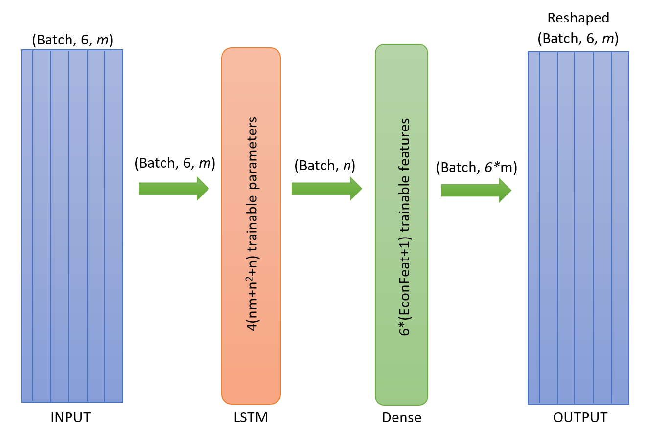

Figure 5: RNN Network Architecture

A LSTM layer with an input dimension of *m* (the number of trainable features including price and economic feature data) and an output dimension of *n* (the units specified in the LSTM layer) have $4\left(nm+n^{2}+n\right)$ trainable parameters for just the LSTM layer alone. LSTM and Dense layer units were limited to reduce the likelihood over overfitting and improve model robustness; 2 or 4 units were used for each LSTM layer.

One method for testing for the best features to include in a RNN model would be to model all possible combinations of price and economic feature data; however, with ten (10) economic features alone, all combinations therein (11C1 + 11C2 + …) would constitute thousands of models; testing of such models would not only be prohibitively time intensive but would also not likely return a statistically-significant improved model (see: *Curse of Dimensionality*). For this reason, three sets of features will be used to train an RNN; they are as follows:

* RNN_1: All 10 non-correlated economic features (*D12*, *b/m*, *tbl*, *AAA*, *ntis*, *infl*, *ltr*, *corpr*, *svar*, *SPvw*) and the real commodity price.
* RRN_2: The economic features with at least ±0.3 correlation with each real commodity price and the real commodity price:
  + Aluminum: D12, tbl, lty
  + Copper/Iron Ore: E12, b/m, tbl, AAA, ntis
  + Nickel/Zinc: E12, ntis
* RRN_3: Just the real commodity price

# Key Findings

The performance results from the four models – baseline random walk model (BLRW), RNN_1, RNN_2, and RNN_3 – for each commodity are illustrated in Figure 6 and detailed in Table 1:

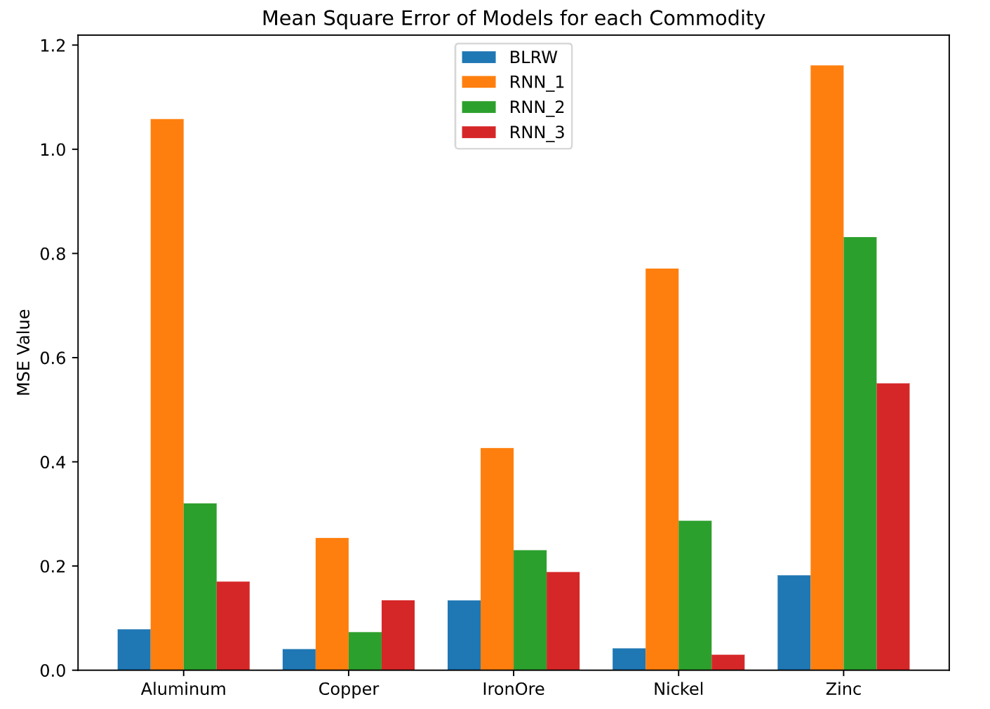

Figure 6: Mean Square Error of Models for each Commodity

Table 1: MSE Values for each Model

|  |  |  |  |  |
| --- | --- | --- | --- | --- |
| Mean Square Error (MSE) Values | | | | |
| **Commodity** | **Baseline Random Walk** | **RNN_1** | **RNN_2** | **RNN_3** |
| **Aluminum** | 0.07854 | 1.0580 | 0.32030 | 0.17010 |
| **Copper** | 0.04054 | 0.2539 | 0.07312 | 0.13420 |
| **Iron Ore** | 0.13400 | 0.4265 | 0.23040 | 0.18850 |
| **Nickel** | 0.04199 | 0.7710 | 0.28690 | 0.02972 |
| **Zinc** | 0.18220 | 1.1610 | 0.83140 | 0.55070 |

Figure 6 and Table 1 identify two trends and conclusions for this model research:

1. Commodity economic feature data had a deleterious effect on recurrent neural network model performance: RNN_3, the model with no economic feature data, performed better than RNN_2, which, in turn, performed better than RNN_1, the model with all economic feature data utilized, for each commodity, except copper which has a superior RNN_2 performance to RNN_3. This trend agrees with literature that including irrelevant variables (e.g., those with low correlation with or predicting capabilities for dependent variables such as those variables included in RNN_1 that were not included in RNN_2) worsen forecasting performance (Wang Y., 2020)
2. The baseline random walk model performed better than all RNN models for each commodity except nickel (i.e., for four out of five industrial metal commodities). Two-sample t-test calculations comparing the means of the baseline random walk and RNN_3 models showed for each commodity except nickel, the mean square error of the baseline model was (with 95% confidence interval) less than the RNN_3 model. Nickel had a significantly less mean square error for the RNN_3 model compared to the baseline (though not for a 99% confidence interval as the other baseline commodity models had); this may have been due to the larger price variance for nickel compared to the other commodities or, since the other four commodity models had the opposite trend, simple statistical luck from the way the nickel model kernelling and testing data aligned.

Figure 7 and Figure 8 illustrate the forecasting difference between the baseline and RNN_3 models by showing three 12-month sample windows randomly selected from the training data, identifying 6 months of training price data against 6 months of forecasted model price and actual price data:

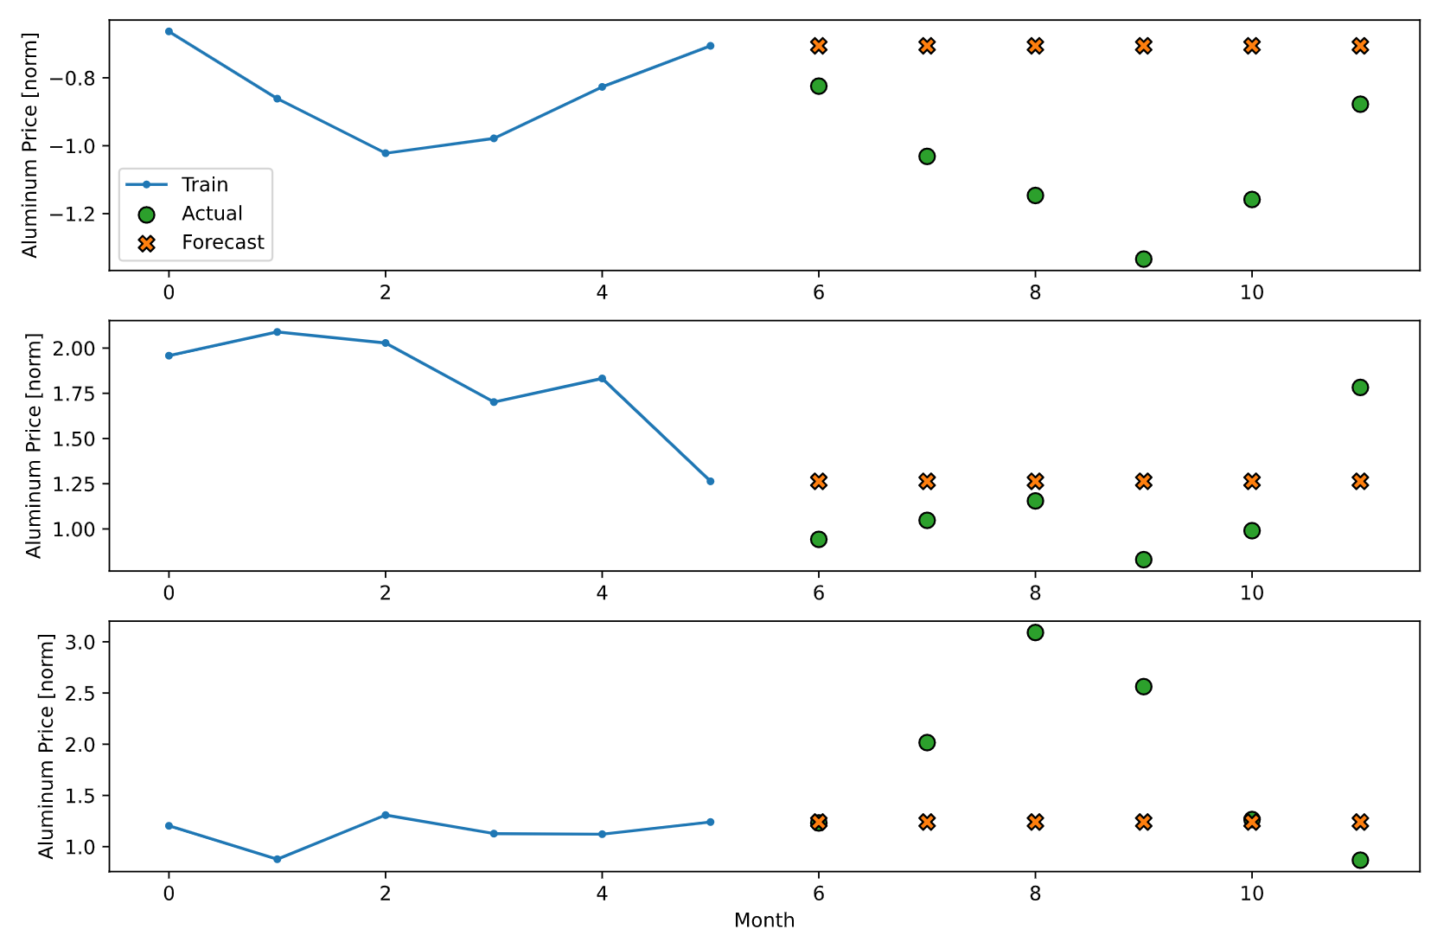

Figure 7: Illustration of Aluminum Baseline Forecasted Versus Actual Values

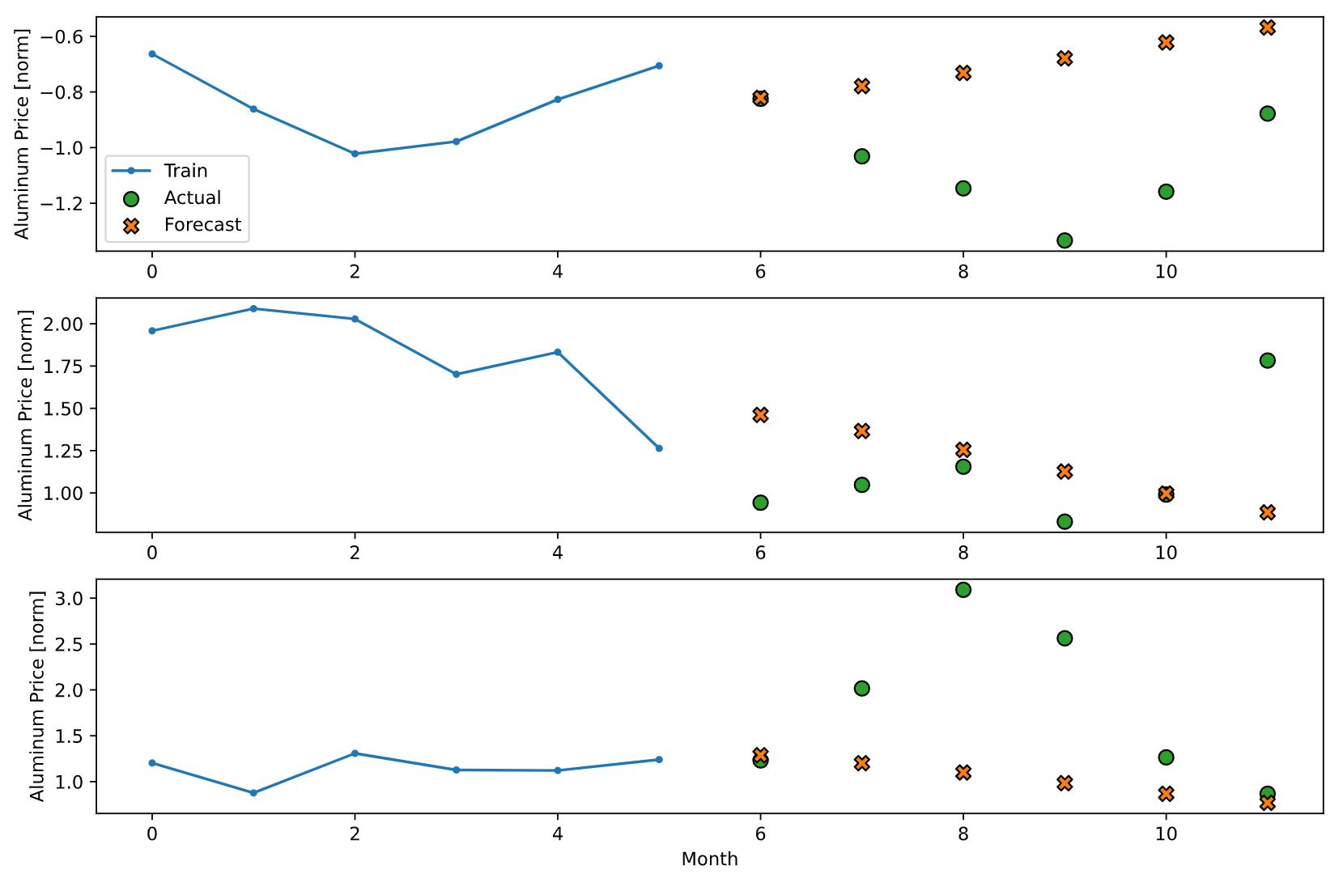

Figure 8: Illustration of Aluminum RNN_3 Forecasted Versus Actual Values

From the mean square error values identifying the baseline model as superior for limiting forecasting error, it can be surmised from the sample windows that RNN_3 model, in general, overfits the model, attempting to anticipate trends or turns in the price data, but ultimately, misinterpreting data and creating larger residual error than the random walk baseline method returns with a simpler and better-averaged model.

Due to the efficacy of the baseline random walk model over each other RNN model tested, the test modeling suggests that the fundamental nature of the commodity data is truly randomly dispersed with no trend. If such were true, any attempt to find a forward trend in the data from economic or autoregressive analysis would be counterproductive for forecasting purposes; this counterproductive trend held for the majority (80%) of commodities modeled, showing a larger mean square error for the best RNN model versus the random walk.

# Project Conclusions

Academic literature investigating the efficacy of regression, autoregressive, and machine learning models for predicting commodity price fluctuations has had mixed results, with some papers identifying statistically significant improvements in commodity forecasting versus a variety of baseline models and still others critiquing published results for a lack of out-of-sample robustness. This study sought to add to the literature of machine learning techniques for forecasting commodities prices by investigating the efficacy of Recurrent Neural Networks (RNNs) derived from commodity price data for five industrial metal commodities (aluminum, copper, iron ore, nickel, and zinc) and economic feature data against a standard autoregressive, integrated, moving average (ARIMA) model derived from the same set of industrial metal commodity price data. Autoregressive analysis for each set of commodity data identified a random walk trend (i.e., an ARIMA(0,1,0) model with no trend constant) for each. With three (3) RNN models derived for each commodity utilizing different combinations of correlated economic features, RNN models were, generally, not found to be superior for forecasting commodity prices over a random walk method; only one (1) RNN model out of fifteen (15) was shown to be statistically superior to baseline random walk model for the testing commodity data (an RNN model for nickel prices utilizing no economic feature data). Testing suggests that the fundamental nature of industrial commodity data is a random walk model.

## Further recommendations for research

This study identified over a relatively limited time frame of 30 years for 5 industrial metal commodities that recurrent neural networks do not surpass the forecasting performance for an autoregressive model. To further explore the benefit of utilizing recurrent neural networks for commodity forecasting, exploration of additional commodities markets, such as the energies (e.g., oil), precious metals (silver, gold) or agricultural markets, may yield specific improved results. It is also common in literature to explore commodities indices for forecasting; specific commodities prices may be more useful for commodity producers and consumers at scale, but indices forecasting may be more beneficial to investing groups. Finally, though the models explored herein showed improved performance for models with less trainable parameters (i.e., those models utilizing fewer model units and independent features), investigating different model architectures, such as utilizing gated recurrent units (GREs) or a 2D convolutional layer in conjunction with an LSTM layer architecture, may also yield improved RNN model results.

# Author Biography

**Rich Gude** is a graduate student in the George Washington University, Columbian School of Arts and Sciences, Data Science Program. His background is in advanced materials research, including carbon nanotube battery configurations and metal alloy testing and development within military and civilian consulting positions for the past 8 years. His personal interests include perfecting his household outdoor grilling space and volleyball.

# References

Alexander, S. S. (1961). Price Movements in Speculative Markets: Trends or Random Walks. *Industrial Management Review, Vol. 2, Iss. 2*.

Bessembinder, H., & Chan, K. (1992). Time-varying risk premia and forecastable returns in futures markets. *Journal of Financial Economics, Vol. 32, Iss. 2*, 169-193.

Boal, F., & Wiederhold, J. (2020). *Rethinking Commodities.* S&P Dow Jones Indices.

Chambers, M. J., & Bailey, R. E. (1996). A Theory of Commodity Price Fluctuations. *Journal of Political Economy*, 924-957.

Chen, Y.-C., Rogoff, K. S., & Rossi, B. (2010). Can Exchange Rates Forecast Commodity Prices? *The Quarterly Journal of Economics, Vol. 125, Iss. 3*, 1145-1194.

Ferrari, D., Ravazzolo, F., & Vespignani, J. (2021). Forecasting energy commodity prices: A large global dataset sparse approach. *Energy Economics, Vol. 98*.

Frankel, J. A. (2014). Effects of Speculation and Interest Rates in a "Carry Trade" Model of Commodity Prices. *Journal of Money and Finance, 2014*.

Furlong, F., & Ingenito, R. (1996). Commodity Prices and Inflation. *FRBSF Economic Review, Num. 2*, 27-47.

Gargano, A., & Timmermann, A. (2014). Forecasting commodity price indexes using macroeconomic and financial predictors. *International Journal of Forecasting, VOl. 30, Iss. 3*, 825-843.

Goyal, A. (2020, April 20). *Amit Goyal: Main Publications*. Retrieved from Personal website of Amit Goyal, Department of Finance, Faculty of Business and Economics, University of Lausanne and Swiss Finance Institute: http://www.hec.unil.ch/agoyal/

Hall, G., & Rust, J. (2021). Estimation of endogenously sampled time series: The case of commodity price speculation in the steel market. *Journal of Econometrics, Vol. 222, Iss. 1, Part A*, 219-243.

Herrera, G. P., Constantino, M., Tabak, B. M., Pistori, H., Su, J.-J., & Naranpanawa, A. (2019). Long-term forecast of energy commodities price using machine learning. *Energy, Vol. 179*, 214-221.

Home, A. (2021, March 5). *MINING.COM.* Retrieved from https://www.mining.com/web/nickel-price-slumps-as-electric-dreams-are-rudely-disturbed/

Liang, C., Ma, F., Li, Z., & Li, Y. (2020). Which types of commodity price information are more useful for predicting US stock market volatility? *Economic Modeling, Vol. 93*, 642-650.

MINING.COM. (2021, March 30). *MINING.COM.* Retrieved from https://www.mining.com/copper-prices-fluctuate-on-china-demand-us-bill/

Schwert, G. (1989). Why Does Stock Market Volatility Change Over Time? *The Journal of Finance, Vol 44, Iss. 5*, 1115-1153.

Shamsher, S. (2021). Financialisation of commodities – Empirical evidence from the Indian financial market. *IIMB Management Review*.

Uma Devi, B., Sundar, D., & Alli, P. (2013). An Effective Time Series Analysis for Stock Trend Prediction Using ARIMA Model for Nifty Midcap-50. *International Journal of Data Mining & Knowledge Management Process (IJDKP), Vol. 3, No. 1*, 65-78.

USGS. (2021, April 20). *National Minerals Information Center: Commodity Statistics and Information*. Retrieved from USGS.GOV: https://www.usgs.gov/centers/nmic/commodity-statistics-and-information

Wang Y., L. &. (2020). Forecasting commodity prices out-of-sample: Can tehcnical indicators help? *Internation Journal of Forecasting, Vol. 36*, 666-683.

Welch, I., & Goyal, A. (2008). A Comprehensive Look at the Empirical Performance of Equity Premium Prediction. *The Review of Financial Studies, Vol. 21*, 1455-1508.

Wimmer, T., Geyer-Klingeberg, J., Hütter, M., Schmid, F., & Rathgeber, A. (2020). The impact of speculation on commodity prices: A Meta-Granger analysis. *Journal of Commodity Markets*, 100148.

Winkelried, D. (2021). Unit roots in real primary commodity prices? A meta-analysis of the Grilli and Yang data set. *Journal of Commodity Markets*.